Learning Report \_ Embebbed Linux



**Document History**

|  |  |  |  |  |  |
| --- | --- | --- | --- | --- | --- |
| **Ver. Rel.**  **No.** | **Release Date** | **Prepared. By** | **Reviewed By** | **Approved By** | **Remarks/Revision Details** |
| 1 |  | Kavya K |  |  |  |
|  |  |  |  |  |  |
|  |  |  |  |  |  |
|  |  |  |  |  |  |
|  |  |  |  |  |  |

**Table of Contents**

# Activity 1:

# video 1:

# 1.Drawback of raspberry pi is no capability of drawing analog inputs.

# 2. It has 4 USB ports, very easy to have a keyboard, mouse, internet connection, display.

# the Beaglebone has a large number of pins. There are two headers.The pin header on the left is referred to as “P9” and the pin header on the right is referred to as “P8”. Pins shaded in red are the various 5V, 3.3V, 1.8V and ground pins. VDD\_ADC is a 1.8 Volt supply and is used to provide a reference for Analog Read functions. The general purpose GPIO pins have been shaded in green. some of these green pins can also be used for UART serial communication. If you want to simmulate analog output, between 0 and 3.3 volts, you can use the PWM pins shaded in purple. The light blue pins can be used as analog in. the Analog In reads between 0 and 1.8 volts. You should not allow these pins to see higher voltages that 1.8 volts. When using these pins, use pins 32 and 34 as your voltage reference and ground, as pin 32 outputs a handy 1.8 volts. The pins shaded in light orange can be used for I2C. The dark orange pins are primarily used for LCD screen applications.

# write the step by step configuration of the boards and set up in the window as well as in linux

### In Windows

* Ethernet cable have to the board to join a local network.
* Power ON the the board.
* Install drivers for the OS and reboot the system.
* Search the IP address 192.168.7.2. this redirects to the local webpage Beagle Bone Black Board.
* Click on the Cloud9 IDE. This opens an Integrated Development Environment where the user codes can be written and executed.
* Open a new terminal and type *ifconifg.*It shows a ip address of the board.
* Install putty or teraterm software. Now, open putty and type the ip address.
* Install the Tight VNC Viewer in the Windows OS and Tight VNC Server in the BBB board. Initialize the VNC server and establish a connection between the both.
* Latest software image should be downloaded.
* Install compression utility to the windows.
* Install SD card programming utility.
* Copy the correct image to your SD card.
* unmount the SD card.
* Boot your board through the SD card.

### In Linux

* Get Install the Gparted app in Linux $ sudo apt install gparted
* Insert card reader in Host pc and select /dev/sdb. Make two partion BOOT and ROOTFS.
* Give file system as fat16 and give label as BOOT.
* Give file name as ext3 and give label as ROOTFS.
* Set the flags.
* Connect the RX of TTL cable to TX of BBB board, TX of TTL cable to RX of BBB board and connect the common ground.
* Power on the board. It loads from the eMMC.
* Save the MLO, uIamge, uEnv.txt and copy the files in the angstrom folder use command 🡪 sudo cp -r \* /media/ltts/ROOTFS/
* Load the memory card to bbb board.
* Open the minicom and boot the BBB with the S2 button pressed.
* It will loads through the SD card.

# ACTIVITY 2- **Differences between Raspberry pie , Dragon, imx7 Sabre, BBB**

|  |  |  |  |  |
| --- | --- | --- | --- | --- |
| Specification | Rasberry Pie | Dragon | imx7 Sabre | BBB |
| Processor | ARM11 processor | * Qualcomm Snapdragon 410 * Quad-core ARM® Cortex® A53 at up to 1.2 GHz per core * 64-Bit capable * Qualcomm Adreno 306 400MHz GPU for PC-class graphics with support foremost * Advanced APIs, including OpenGL ES 3.0, OpenCL, DirectX, and content security | * Two Arm® Cortex®-A7 core operating up to 1 GHz * Single Arm Cortex -M4 core operating up to 200 MHz | ARM Cortex-A8 processor. |
| Memory | 512 MB SDRAM is used. | * 1GB LPDDR3, 533MHz   + 8GB eMMC 4.51   + SD 3.0 (UHS-I) | * 1 GB DDR3, 533 MHz * eMMC expansion footprint * NAND flash expansion footprint * QSPI flash expansion footprint | 512 MB DDR3L is used. |
| Power Management | 700mA (3.5W) | Power: +6.5V to +18V | PF3000 PMIC | 210mA (1.05W) |
| Wireless |  | * WLAN 802.11 b/g/n 2.4GHz * Bluetooth® wireless technology 4.1 * One USB 2.0 micro B (device mode only) * Two USB 2.0 (host mode only) * GPS * On-board GPS antenna * On-board BT and WLAN antenna | * 802.11 a/b/g/n/ac Wi-Fi® on board * Bluetooth V4.0 + EDR on board |  |
| UART | It uses 1 UART to transmit and receive serial data. | UART via USB port | UART via USB port | It uses 5 UART to transmit and receive serial data. |
| No. of I/O pins | It has 8 Digital, 0 Analog pins. | 40-pin low-speed |  | It has 65 Digital, 7 Analog pins. |
| FLASH | It has dedicated SD Card socket for loading operating system. | SD Card Method - Install and boot from eMMC and  SD card | NAND flash and QSPI flash | It uses 4GB (micro SD) for loading OS and data storage. |

# ACTIVITY 3- **Differences in different versions of BBB and write the evolution of the Beagle bone.**

|  |  |  |  |  |  |  |  |
| --- | --- | --- | --- | --- | --- | --- | --- |
|  | PocketBeagle | BeagleBoard-X15 | BeagleBone Black | BeagleBone | BeagleBoard-xM | BeagleBoard |  |
| Release Date: | September 21, 2017[[38]](https://en.wikipedia.org/wiki/BeagleBoard" \l "cite_note-38) | 23 September 2016[[39]](https://en.wikipedia.org/wiki/BeagleBoard" \l "cite_note-39) | April 23, 2013 | October 31, 2011 | September 14, 2010 | July 28, 2008 |  |
| [SoC](https://en.wikipedia.org/wiki/System_on_a_chip) | OSD3358-SM | Sitara AM5728[[40]](https://en.wikipedia.org/wiki/BeagleBoard" \l "cite_note-40) | AM3358/9 | | DM3730 | [OMAP3530](https://en.wikipedia.org/wiki/OMAP3530) |  |
| [CPU](https://en.wikipedia.org/wiki/Central_processing_unit) | Sitara AM3358 ARM Cortex-A8 | [Dual ARM Cortex-A15](https://en.wikipedia.org/wiki/ARM_Cortex-A15) + [Dual ARM M4 (212 MHz)](https://en.wikipedia.org/wiki/ARM_Cortex-M) + Quad PRU (200 MHz) | [Cortex-A8](https://en.wikipedia.org/wiki/ARM_Cortex-A8) + Dual PRU (200 MHz) | | | | |
| Frq ([MHz](https://en.wikipedia.org/wiki/MHz)) | 1000 | 1500 | 1000 | 720 | 1000 | 720 |  |
| [GPU](https://en.wikipedia.org/wiki/Graphics_processing_unit) | [PowerVR SGX530](https://en.wikipedia.org/wiki/PowerVR" \l "Series_5) | [Dual PowerVR SGX544](https://en.wikipedia.org/wiki/PowerVR" \l "Series_5) | [PowerVR SGX530](https://en.wikipedia.org/wiki/PowerVR" \l "Series_5)[[41]](https://en.wikipedia.org/wiki/BeagleBoard" \l "cite_note-ti.com-41)[[42]](https://en.wikipedia.org/wiki/BeagleBoard" \l "cite_note-42)[[43]](https://en.wikipedia.org/wiki/BeagleBoard" \l "cite_note-43) (200 MHz) | | | |  |
| [DSP](https://en.wikipedia.org/wiki/Digital_signal_processor) | N/A | Dual [TMS320C66x](https://en.wikipedia.org/wiki/Texas_Instruments_TMS320)[[41]](https://en.wikipedia.org/wiki/BeagleBoard" \l "cite_note-ti.com-41) (700 MHz) | N/A | N/A | [TMS320C64x+](https://en.wikipedia.org/wiki/Texas_Instruments_TMS320)[[44]](https://en.wikipedia.org/wiki/BeagleBoard" \l "cite_note-44) (800 MHz) | [TMS320C64x+](https://en.wikipedia.org/wiki/Texas_Instruments_TMS320)[[41]](https://en.wikipedia.org/wiki/BeagleBoard" \l "cite_note-ti.com-41) (520 MHz) |  |
| Onboard storage: | 4KB of EEPROM, [microSD](https://en.wikipedia.org/wiki/MicroSD) card slot | 8-bit [eMMC](https://en.wikipedia.org/wiki/EMMC) 4 GB, [microSD](https://en.wikipedia.org/wiki/MicroSD) card | 8-bit [eMMC](https://en.wikipedia.org/wiki/EMMC) (Rev B: 2 GB [Ångström](https://en.wikipedia.org/wiki/Ångström_distribution) pre-installed, Rev C: 4 GB [Debian](https://en.wikipedia.org/wiki/Debian) pre-installed ), [microSD](https://en.wikipedia.org/wiki/MicroSD) card 3.3 V Supported (No Card Supplied) | [microSD](https://en.wikipedia.org/wiki/MicroSD) card 3.3 V Supported (card supplied with [Ångström](https://en.wikipedia.org/wiki/Ångström_distribution)) | [microSD](https://en.wikipedia.org/wiki/MicroSD) card Supported (card supplied with [Ångström](https://en.wikipedia.org/wiki/Ångström_distribution)) | 256MB NAND Flash, SD/MMC card |  |
| Onboard network: | N/A | Dual [Gigabit Ethernet](https://en.wikipedia.org/wiki/Gigabit_Ethernet) | [Fast Ethernet](https://en.wikipedia.org/wiki/Fast_Ethernet) (MII based) | [Fast Ethernet](https://en.wikipedia.org/wiki/Fast_Ethernet) (MII based) | [Fast Ethernet](https://en.wikipedia.org/wiki/Fast_Ethernet) (via USB hub with Ethernet) | N/A |  |
| [USB](https://en.wikipedia.org/wiki/USB) ports: | 1 x Micro USB Type B | 3 x USB 3.0 Type A Host 4 x USB 2.0 Host 1 x Micro USB Type B | 1 x Standard A host port (direct). 1x mini B device port (direct) | 1 x Standard A host port (direct). 1x mini B device port (via hub) | 4 x Standard A host port (via hub with Ethernet). 1x mini AB OTG port (direct) | 1 x Standard A host port (direct). 1x mini AB OTG port (direct) |  |
| Memory (SDRAM): | 512 [MiB](https://en.wikipedia.org/wiki/Mebibyte) [DDR3](https://en.wikipedia.org/wiki/DDR3_SDRAM) | 2048 [MiB](https://en.wikipedia.org/wiki/Mebibyte) [DDR3L](https://en.wikipedia.org/wiki/DDR3_SDRAM) | 512 [MiB](https://en.wikipedia.org/wiki/Mebibyte) [DDR3](https://en.wikipedia.org/wiki/DDR3_SDRAM) | 256 [MiB](https://en.wikipedia.org/wiki/Mebibyte) [DDR2](https://en.wikipedia.org/wiki/DDR2_SDRAM) | 512 [MiB](https://en.wikipedia.org/wiki/Mebibyte) [DDR2](https://en.wikipedia.org/wiki/DDR2_SDRAM) | 128 [MiB](https://en.wikipedia.org/wiki/Mebibyte) (rev B) [DDR](https://en.wikipedia.org/wiki/DDR_SDRAM) 256 [MiB](https://en.wikipedia.org/wiki/Mebibyte) (rev C+) [DDR](https://en.wikipedia.org/wiki/DDR_SDRAM) |  |
| Video outputs: | none | [HDMI](https://en.wikipedia.org/wiki/HDMI), LCD via Expansion | [Micro-HDMI](https://en.wikipedia.org/wiki/Micro-HDMI), cape add-ons | cape add-ons | [DVI-D](https://en.wikipedia.org/wiki/DVI-D), [S-Video](https://en.wikipedia.org/wiki/S-Video) | |  |
| Audio outputs: | none | [HDMI](https://en.wikipedia.org/wiki/HDMI), AIC3104 (Stereo In/Out) | [Micro-HDMI](https://en.wikipedia.org/wiki/Micro-HDMI), cape add-ons | cape add-ons | [3.5mm audio jack](https://en.wikipedia.org/wiki/3.5mm_audio_jack) | |  |
| Size: | 56mm x 35mm x 5mm | 107 mm × 102 mm (4.2 in × 4.0 in)[[45]](https://en.wikipedia.org/wiki/BeagleBoard" \l "cite_note-45) | 86.40 mm × 53.3 mm (3.402 in × 2.098 in) | ? | 78.74 mm × 76.2 mm (3.1 in × 3.0 in) | ? |  |
| Weight: | 10 grams / 0.35 ounces | TBA | 39.68 g (1.400 oz)[[46]](https://en.wikipedia.org/wiki/BeagleBoard" \l "cite_note-46) | ? | ? | ? |  |
| Power ratings: | 150 mA @ 5 V | 210–460 mA @5 V | 210–460 mA @5 V | 300–500 mA @5 V | ? | ? |  |
| Power source: | micro USB port or I/O pins | 2.5 mm × 5.5 mm 12 V jack | [Mini USB](https://en.wikipedia.org/wiki/Mini_USB) or 2.1 mm x 5.5 mm 5 V jack | | | |  |
| Low-level peripherals: | 3x[UART](https://en.wikipedia.org/wiki/Universal_asynchronous_receiver/transmitter), 4× PWM, 2× [SPI](https://en.wikipedia.org/wiki/Serial_Peripheral_Interface_Bus), 2× [I²C](https://en.wikipedia.org/wiki/I²C), 2x [CAN bus](https://en.wikipedia.org/wiki/CAN_bus) | 7x[UART](https://en.wikipedia.org/wiki/Universal_asynchronous_receiver/transmitter), LCD, GPMC, 1× [SPI](https://en.wikipedia.org/wiki/Serial_Peripheral_Interface_Bus), 1x [I²C](https://en.wikipedia.org/wiki/I²C), 1x [CAN bus](https://en.wikipedia.org/wiki/CAN_bus) | 4x[UART](https://en.wikipedia.org/wiki/Universal_asynchronous_receiver/transmitter), 8× PWM, LCD, GPMC, MMC1, 2× [SPI](https://en.wikipedia.org/wiki/Serial_Peripheral_Interface_Bus), 2× [I²C](https://en.wikipedia.org/wiki/I²C), A/D Converter, 2× [CAN bus](https://en.wikipedia.org/wiki/CAN_bus), 4 Timers | 4x[UART](https://en.wikipedia.org/wiki/Universal_asynchronous_receiver/transmitter), 8× PWM, LCD, GPMC, MMC1, 2× [SPI](https://en.wikipedia.org/wiki/Serial_Peripheral_Interface_Bus), 2× [I²C](https://en.wikipedia.org/wiki/I²C), A/D Converter, 2× [CAN bus](https://en.wikipedia.org/wiki/CAN_bus), 4 Timers, FTDI USB to serial, JTAG via USB | McBSP, DSS, I²C, UART, LCD, McSPI, PWM, JTAG, camera interface | McBSP, DSS, I²C, UART, McSPI, PWM, [JTAG](https://en.wikipedia.org/wiki/Joint_Test_Action_Group) |  |

REFERENCES

**Activity : EVOLUTION O BEAGLE BONE BLACK**

**Revision C**

* This revision increases the eMMC from 2GB to 4GB.

1) Complaints from the community about lack of space left in the eMMC.  
2) For those worried about their eMMC wearing out, the added space will help in the area of moving the data around to prevent wear out. Assuming of course you don't try and use it all.  
3) Concerns over the long-term availability of the 2GB device. 4GB is currently the low end of the offering. This also gives us two sources.

**Revision B**

* This version moves to the AM3358BZCZ100 processor as we are no longer able to get the limited production version of the AM3359AZCZ100.
* No changes in features or operation of the board resulted from this change.

**Revision A6A**

* Added optional zero ohm resistor to tie GND\_OSC1 to system ground.
* Changed C106 to a 1uF capacitor.
* Changed C24 to a 2.2uF capacitor.

**Revision A6**

* Based on notification from TI, in random instances there could be a glitch in the SYS\_RESETn signal from the processor where the SYS\_RESETn signal was taken high for a momentary amount of time before it was supposed to. Noise issues were observed in other designs where the clock oscillator was getting hit due to a suspected issue in ground bounce. A zero ohm resistor was added to connect the OSC\_GND to the system ground.

**Revision A5C**

Production had some fallout of boards when running the HDMI tests in the previous production run. Resistor values were tweaked to improve the test results.  
1) Changed R46,R47,R48 to a 0 ohm.  
2) Changed R45 to a 22 Ohm.

**Revision A5B**

* Updated the PCB to incorporate the modification that was being done on Rev A5A. There is NO DIFFERENCE AT ALL in functionality between REV A5A and REV A5B.
* Made the LEDs dimmer for those that could not sleep due to the brightness of the LEDs.

**Revision A5A**

* Boards are built using the XAM3359AZCZ100 processor.
* PCB Change...LCD noise issue was resolved by adding 47pf bypass caps on some of the LCD signals.

**Revision A4B**

Added a 100K pull down resistor between pins 1 and 4 of J1 to fix the serial port issue.

**Revision A4A**

Incorporated the capacitors to fix the noise issue on the display

**Revision A4**

First prototype release version of the board. Limited distribution. One notable issue here is that the board has an AM3352 processor instead of an AM3359, despite how the part is marked. Part was mismarked as an AM3359. The SGX and PRU are not operational.

**Activity : PINOUT HEADERS**

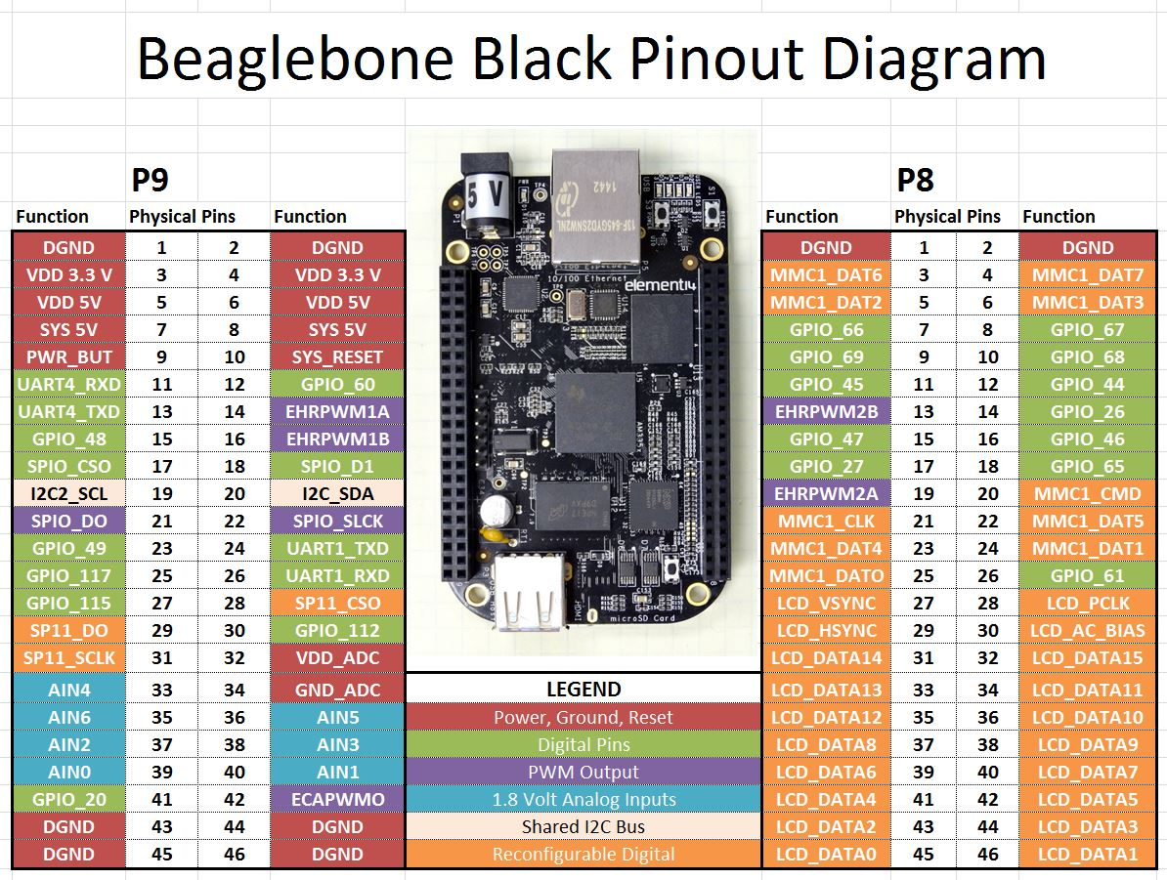

|  |  |  |  |
| --- | --- | --- | --- |
| Pin expansion header for beaglebone black | | | |
|
| P9 expansion header | | P8 expansion header | |
|
| PIN No | NAME | PIN NO | NAME |
| Power output | | | |
| 3 , 4 | 3.3 V | 1,2,43,4546 | DGND |
| 5, 6 | 5V (VDD) | 1 ,2 | DGND |
| 7, 8 | 5V (SYS) |  | |
| UART Communication | | | |
| 37 | UART5\_TX | 24 | UART1\_TX |
| 38 | UART5\_RX | 26 | UART1\_RX |
|  | | 21 | UART2\_TX |
| 22 | UART2\_RX |
| 11 | UART4\_TX |
| 13 | UART4\_RX |
| SPI Communication | | | |
| 17 | SPI0\_CS0 |  | |
| 21 | SPI0\_D0 |
| 18 | SPI0\_D1 |
| 22 | SPI0\_SCLK |
| 28 | SPI1\_CS0 |
| 29 | SPI1\_D0 |
| 30 | SPI1\_D1 |
| 31 | SPI1\_SCLK |
| I2C Communication | | | |
| 17 | I2C1\_SCL |  | |
| 18 | I2C1\_SDA |
| 19 | I2C2\_SCL |
| 20 | I2C2\_SDA |
| PWM Channel | | | |
| 36 | PWM1A | 22 | PWM0A |
| 34 | PWM1B | 21 | PWM0B |
| 45 | PWM2A | 31 | PWM0A |
| 46 | PWM2B | 29 | PWM0B |
| 19 | PWM2A | 14 | PWM1A |
| 13 | PWM2B | 16 | PWM1B |
| 42 | ECAPPWM0 | 42 | ECAPPWM0 |
| 28 | ECAPPWM2 | 28 | ECAPPWM2 |
| eMMC Support Pins | | | |
|  | | 20 | MMC1\_CMD |
| 21 | MMC1\_CLK |
| 25 | MMC1\_DAT0 |
| 24 | MMC1\_DAT1 |
| 5 | MMC1\_DAT2 |
| 6 | MMC1\_DAT3 |
| 23 | MMC1\_DAT4 |
| 22 | MMC1\_DAT5 |
| 3 | MMC1\_DAT6 |
| 4 | MMC1\_DAT7 |
| HDMI LCD Interface Pins | | | |
|  | | 27 | LCD\_VSYNC |
| 28 | LCD\_PCLK |
| 29 | LCD\_HSYNC |
| 30 | LCD\_AC\_BIAS |
| 31 | LCD\_DATA14 |
| 32 | LCD\_DATA15 |
| 33 | LCD\_DATA13 |
| 34 | LCD\_DATA11 |
| 35 | LCD\_DATA12 |
| 36 | LCD\_DATA10 |
| 37 | LCD\_DATA8 |
| 38 | LCD\_DATA9 |
| 39 | LCD\_DATA6 |
| 40 | LCD\_DATA7 |
| 41 | LCD\_DATA4 |
| 42 | LCD\_DATA5 |
| 43 | LCD\_DATA2 |
| 44 | LCD\_DATA3 |
| 45 | LCD\_DATA0 |
| 46 | LCD\_DATA1 |
| Analog to Digital Converter | | | |
| 39 | AIN0 |  | |
| 40 | AIN1 |
| 37 | AIN2 |
| 38 | AIN3 |
| 33 | AIN4 |
| 36 | AIN5 |
| 35 | AIN6 |
| 32 | VDD\_ADC |
| 34 | GND\_ADC |
| Timers | | | |
|  | | 10 | TIMER1 |
| 9 | TIMER2 |
| 7 | TIMER4 |
| 8 | TIMER7 |
| GPIO Pins | | | |
| 3 | GPIO\_38 | 11 | GPIO\_30 |
| 4 | GPIO\_39 | 12 | GPIO\_60 |
| 5 | GPIO\_34 | 13 | GPIO\_31 |
| 6 | GPIO\_35 | 14 | GPIO\_40 |
| 7 | GPIO\_66 | 15 | GPIO\_48 |
| 8 | GPIO\_67 | 16 | GPIO\_51 |
| 9 | GPIO\_69 | 17 | GPIO\_4 |
| 10 | GPIO\_68 | 18 | GPIO\_5 |
| 11 | GPIO\_45 | 19 | GPIO\_13 |
| 12 | GPIO\_44 | 20 | GPIO\_12 |
| 13 | GPIO\_23 | 21 | GPIO\_3 |
| 14 | GPIO\_26 | 22 | GPIO\_2 |
| 15 | GPIO\_47 | 23 | GPIO\_49 |
| 16 | GPIO\_46 | 24 | GPIO\_15 |
| 17 | GPIO\_27 | 25 | GPIO\_117 |
| 18 | GPIO\_65 | 26 | GPIO\_14 |
| 19 | GPIO\_22 | 27 | GPIO\_125 |
| 20 | GPIO\_63 | 28 | GPIO\_123 |
| 21 | GPIO\_62 | 29 | GPIO\_111 |
| 22 | GPIO\_37 | 30 | GPIO\_112 |
| 23 | GPIO\_36 | 31 | GPIO\_110 |
| 24 | GPIO\_33 | 41 | GPIO\_20 |
| 25 | GPIO\_32 | 42 | GPIO\_7 |
| 26 | GPIO\_61 |  | |
| 27 | GPIO\_86 |
| 28 | GPIO\_88 |
| 29 | GPIO\_87 |
| 31 | GPIO\_10 |
| 32 | GPIO\_11 |
| 33 | GPIO\_9 |
| 34 | GPIO\_81 |
| 35 | GPIO\_8 |
| 36 | GPIO\_80 |
| 37 | GPIO\_78 |
| 38 | GPIO\_79 |
| 39 | GPIO\_76 |
| 40 | GPIO\_77 |
| 41 | GPIO\_74 |
| 42 | GPIO\_75 |
| 43 | GPIO\_72 |
| 44 | GPIO\_73 |
| 45 | GPIO\_70 |
| 46 | GPIO\_71 |

**ACTIVITY : 1. Testing MLO image on BBB**

* Copy the MLO file and keep it in the BOOT folder of the SD card.
* Insert the memory card to the bbb .
* Connect the TTL cable to the BBB.
* Open the Minicom in the terminal.
* Press the S2 button to load from the SD card.
* It runs the MLO file and search for uIamge. As uImage is not present It shows a error.

PENDING : screen shot

1. **Testing U-boot image on BBB**

* Copy the Uimage file and keep it in the BOOT folder of the SD card.
* Insert the memory card to the bbb .
* Connect the TTL cable to the BBB.
* Open the Minicom in the terminal.
* Press the S2 button to load from the SD card.
* It runs the uIamge file and loads to uboot.
* Search for uEnv.txt. It shows the uEnv.txt is not found.

**PENDING : screenshot**

**ACTIVITY : BOOT SEQUENCE AFTER BOOTING**

**PENDING**

**ACTIVITY : COMPILATION COMMANDS**

1. **U\_BOOT COMPILATION :**
2. **DISTCLEAN :** deletes all the previously compiled/generated object files.

make ARCH=arm CROSS\_COMPILE=arm-linux-gnueabihf- distclean

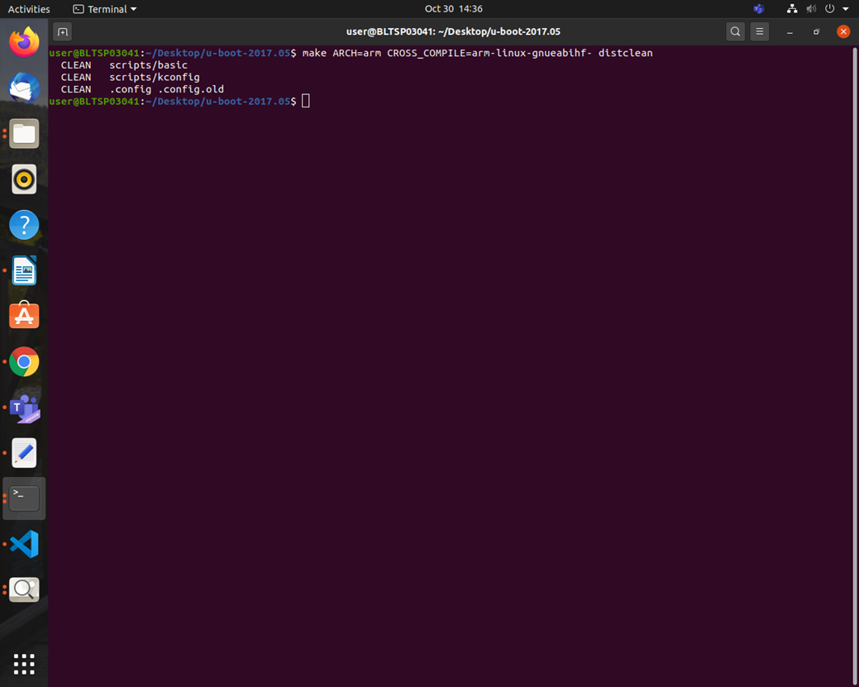

1. apply board default configuration for uboot

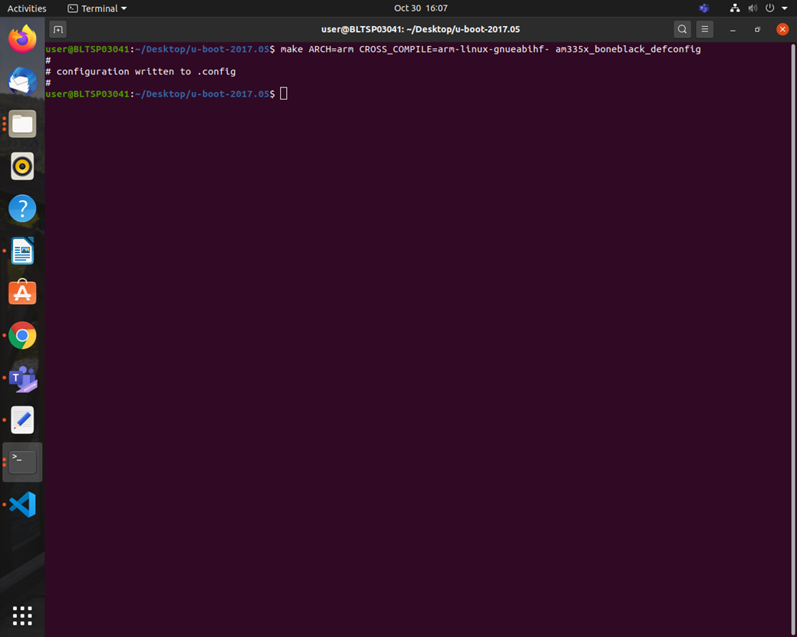

1. run menuconfig, if you want to do any settings other than default configuration .

make ARCH=arm CROSS\_COMPILE=arm-linux-gnueabihf- menuconfig

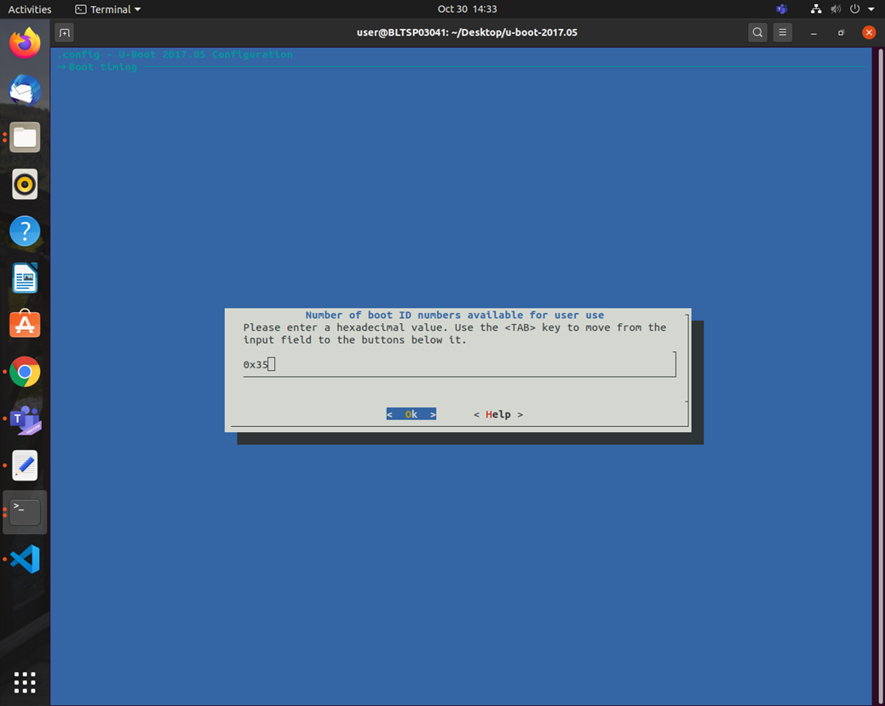

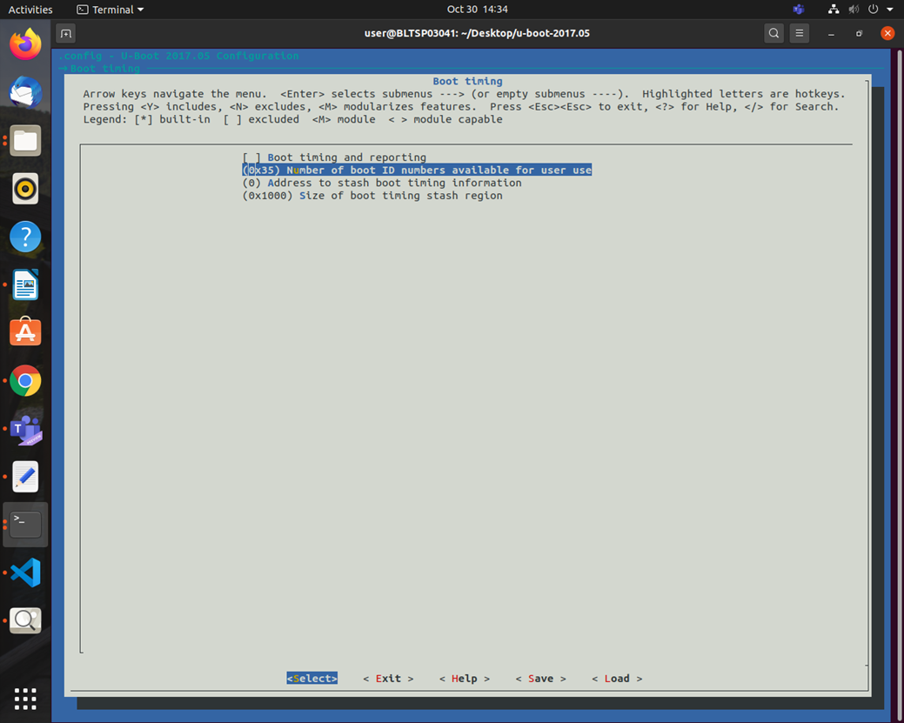

1. compile

make ARCH=arm CROSS\_COMPILE=arm-linux-gnueabihf- -j4

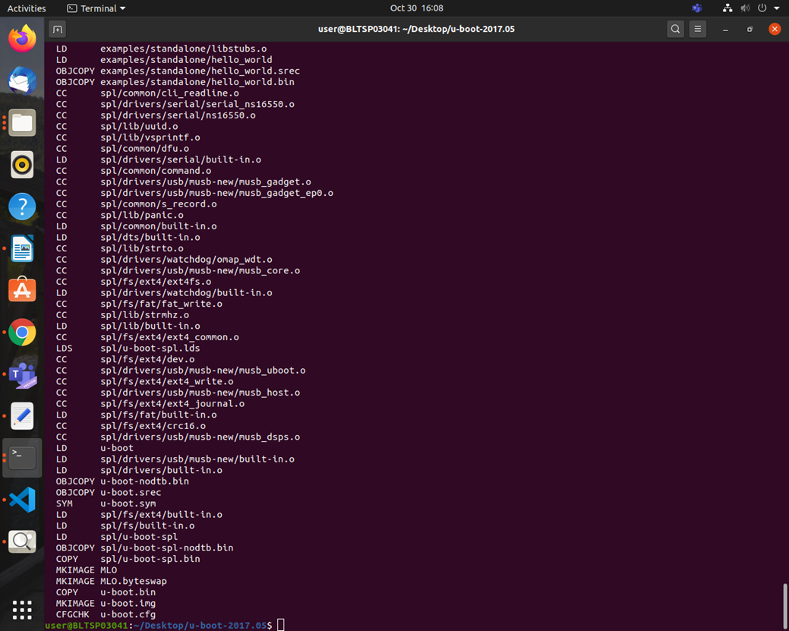

1. **LINUX COMPILATION**
2. make ARCH=arm CROSS\_COMPILE=arm-linux-gnueabihf- distclean

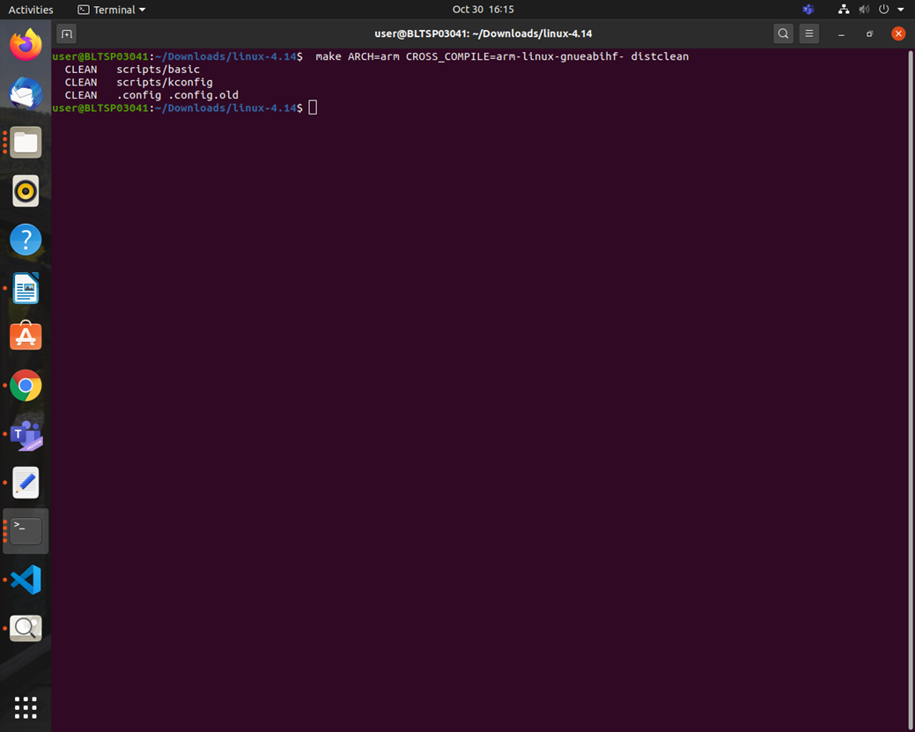

1. make ARCH=arm CROSS\_COMPILE=arm-linux-gnueabihf- bb.org\_defconfig

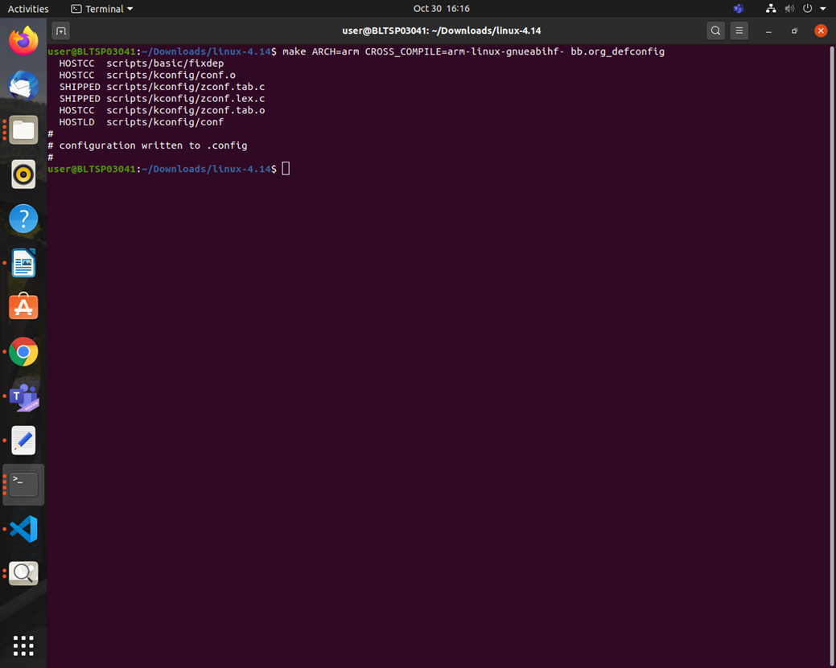

1. make ARCH=arm CROSS\_COMPILE=arm-linux-gnueabihf- menuconfig

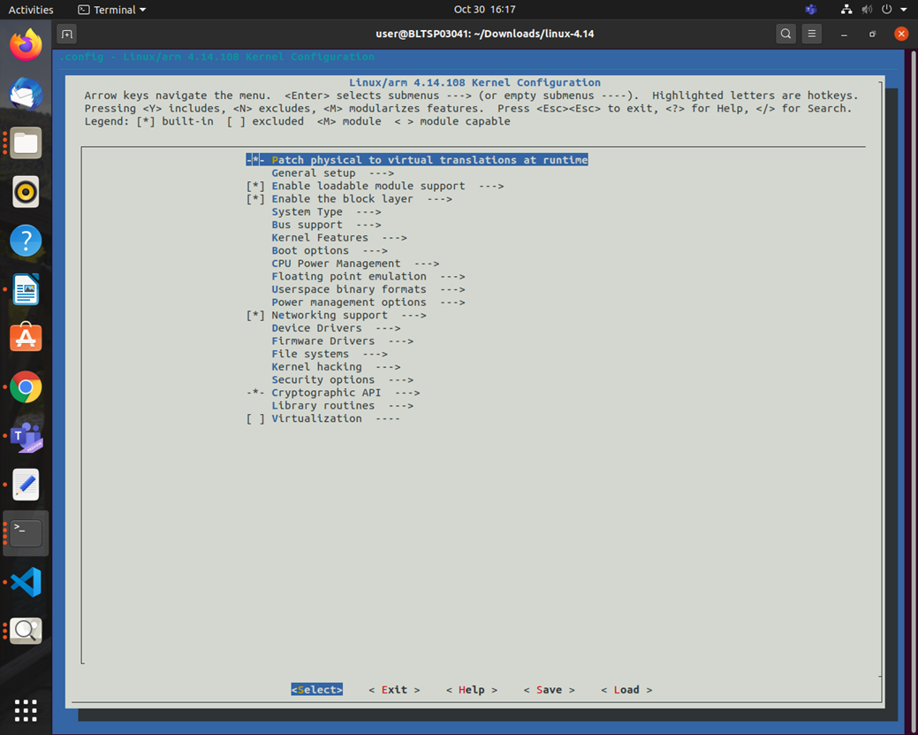

4.make ARCH=arm CROSS\_COMPILE=arm-linux-gnueabihf- uImage dtbs LOADADDR=0x80008000 -j4

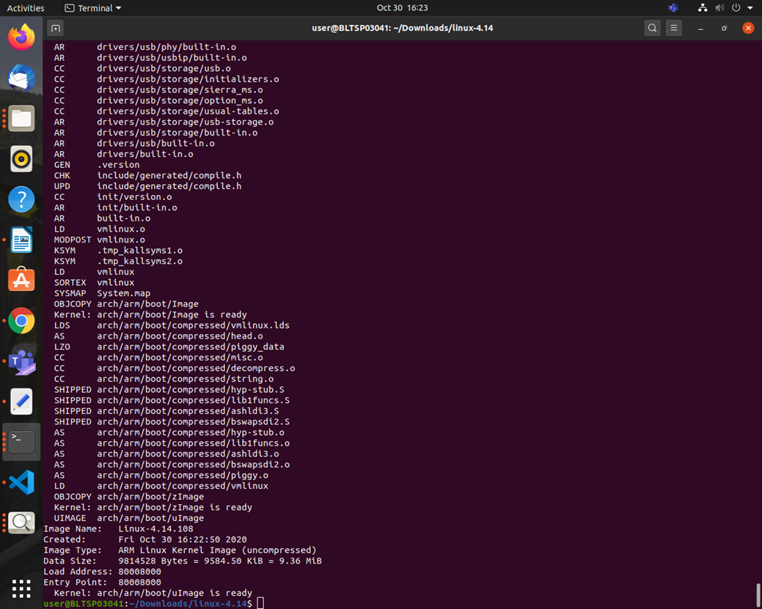

1. make ARCH=arm CROSS\_COMPILE=arm-linux-gnueabihf- -j4 modules

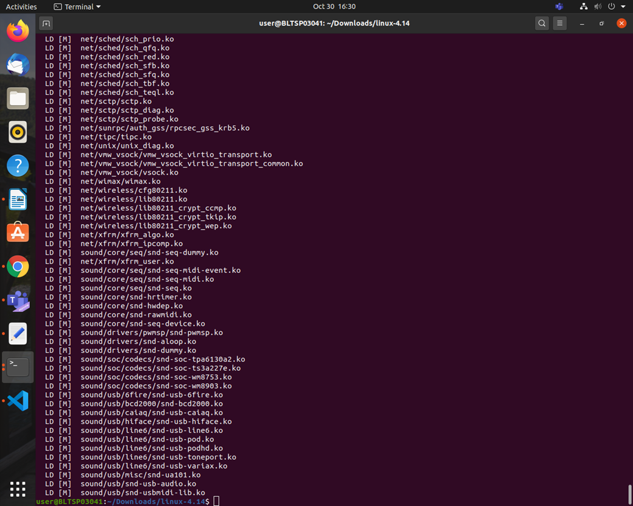

6.make ARCH=arm CROSS\_COMPILE=arm-linux-gnueabihf- INSTALL\_MOD\_PATH=<path of the RFS> modules\_install

PENDING: SCREENSHOT

1. BUSY BOX COMPILATION
2. make ARCH=arm CROSS\_COMPILE=arm-linux-gnueabihf- defconfig

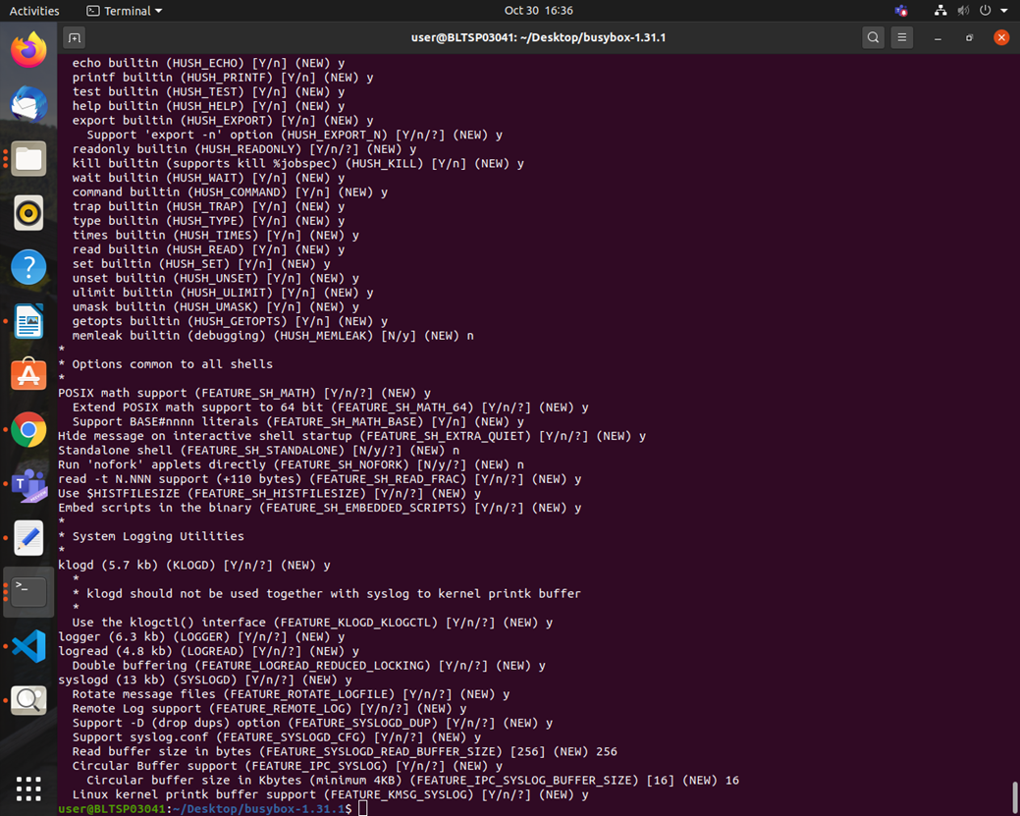

2.change default settings if you want

make ARCH=arm CROSS\_COMPILE=arm-linux-gnueabihf- menuconfig

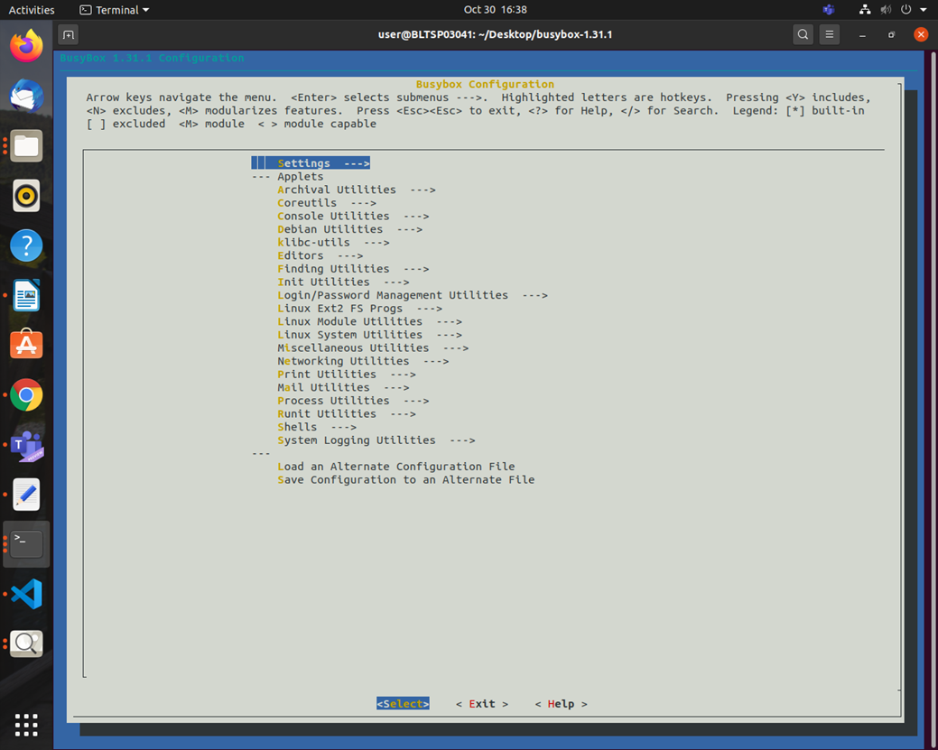

3.generate the busy box binary and minimal file system

make ARCH=arm CROSS\_COMPILE=arm-linux-gnueabihf- CONFIG\_PREFIX=<install\_path> install

PENDING : SCREENSHOT

1. **BUILD ROOT COMPILATION**

PENDING : SCREENSHOT

1. DROP BEAR COMPILATION

PENDING : SCREENSHOT

REFERENCES

[1]https://en.wikipedia.org/wiki/BeagleBoard

[2]https://beagleboard.org/boards

[3]https://www.nxp.com/design/development-boards/i-mx-evaluation-and-development-boards/sabre-board-for-smart-devices-based-on-the-i-mx-7dual-applications-processors:MCIMX7SABRE

[4]https://www.educba.com/raspberry-pi-3-vs-beaglebone-black/

[5]https://components101.com/microcontrollers/beaglebone-black-pinout-datasheet